Dear Year ? Student

Welcome to E Apprenticeship Related Instruction Training. Thank you for registering! This system is designed for you to complete one lesson per week. It is important to maintain the pace to complete the training program. This site is very user friendly but may be confusing in the beginning. Feel free to email the E Apprenticeship Director, Pam Fuhrer at [Etraining@iecchesapeake.com](mailto:Etraining@iecchesapeake.com), with any questions you may have.

STEP 1: LOG INTO THE SYSTEM

1. Go to <https://iec-chesapeake.eitprep.com/login>
2. Click on the E Apprenticeship link toward the upper left of your screen to log in.
3. Enter your email address and password to log in. Watch for your login information in a separate email from [jfuhrer.eapprenticeship@iecchesapeake.com](mailto:jfuhrer.eapprenticeship@iecchesapeake.com).

You must type in your username and password as it is given, using upper and lowercase as shown, or you will not be able to access the system.

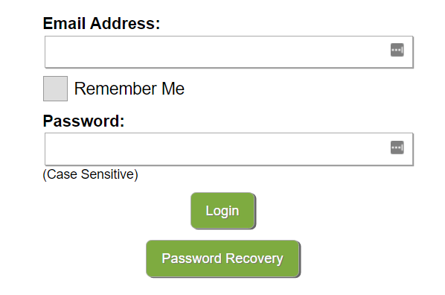

STEP 2: NAVIGATE THE SYSTEM

Explore the system by placing your cursor on the 4 links across the top.

Home About E Apprenticeship Contact Us

REVIEW THE FOLLOWING AREAS BEFORE YOU BEGIN YOUR TRAINING

1. Hover your cursor over the E Apprenticeship link. You will see a drop-down menu containing the following: **E Classroom, Classroom Resources, E Calendar, Using the LMS and Logout**
2. In the E Apprenticeship drop-down menu, use your cursor to click on E Classroom. Explore this page.
3. Scroll down to find information regarding the Reading Worksheets.

Reading worksheets are to be completed by **Monday** of each week. The lesson posted on Monday is the Reading Worksheet due that day.

1. You will also see the “**Calendar**” link below the green bar. Click on the calendar according to your R Code. This is where you will see which lesson you should be on and/or completed each week according to your assigned R(#) code. Check the top of your calendar for your assigned “R” Calendar Code.
2. Also on the E Classroom page, you will find your **Instructor Contact** information and the semester of training in which you are enrolled.

**If you don’t see the above items you may need to click on the + sign on the right side of the green “Classroom” ribbon at the bottom of the page to expand it and reveal the E Classroom page contents.

1. Return to the E Apprenticeship drop-down menu. Click on Classroom Resources.

Here you will find the following.

1. Online Syllabus
2. “How To” Study Guide for online learning
3. Year ? tab specific to Year ? information
4. List of Labs required for each year.
5. Return to the E Apprenticeship drop-down menu. Click on E Calendar.

It will post information and events, including information regarding your mandatory WEEKLY INSTRUCTOR SESSION. The instructor session time slots are highlighted in orange on the calendar.

1. Return to the E Apprenticeship drop-down menu. Click on Using the LMS.

LMS stands for *Learning Management System*.

Read this before you begin training and use it for reference.

1. Use the E Apprenticeship drop-down menu. Click on Logout when ready to exit the system.

STEP 3: ACCESS YOUR TRAINING

1. Hover your cursor over the E Apprenticeship link.
2. From the drop-down menu click on E Classroom
3. Scroll down until you see the training title you were assigned. Click on the blue text link. Reference example below.

1. The next page will show the **semester** in which you will be working. Reference example below.

**Y1S1=Year ? Semester 1

Once you select a chapter (e.g. L102-Tools and Fasteners), you can use the arrows in the gray bar on the upper right-hand side of the page or the “**Previous Page**” and “**Next Page**” buttons at the bottom of the page. There are also highlighters, readers, and other helpful tools in the upper right side of your page. (Shown below)

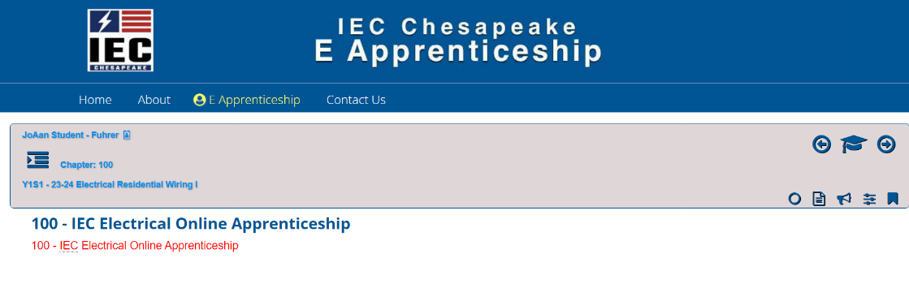

STEP 4: BEGIN TRAINING

Now that you have an overview of the online system, follow the steps below:

1. Pull out your Student Manual, student workbook, and textbook.
2. Open your student manual to the first Lesson, which is L ?01.

The first page of the Lesson chapter is laid out as Homework and Objectives.

1. Read your lesson per the assigned reading instructions. Follow the online training.
2. If you have a **READING WORKSHEET** at the end of your lesson, it is **highly recommended** to complete this worksheet by the corresponding Monday due date.
3. Go back to L ?01.1 at the beginning of the lesson. Read that Objective.
4. At the end of the lesson find Objective ?01.1
5. Compare that Objective Homework in your student workbook
6. Locate the next objective in the lesson e.g. ?01.2
7. Repeat the process
8. Once you complete the homework in your student manual, log into the online system.
9. Complete the homework objectives online.
10. Complete the Safety Homework online.
11. Complete the lab if there is one included in the lesson information online.
12. Complete the end of chapter quizzes online.

E Apprenticeship Grading Policy

1. Incomplete homework, quizzes, and lessons will receive zero credit upon completion of the midterm exam or upon completion of any lesson prescribed after the midterm exam, per the syllabus. Once the midterm is complete, you will not be able to make up any incomplete work for credit.
2. Incomplete homework, quizzes, and lessons will receive zero credit upon completion of the final exam. Once the final exam is complete, you will not be able to make up any incomplete work for credit.
3. All labs must be completed and graded to pass the course.
4. Students must achieve a 70% cumulative grade to pass the course.

Mandatory weekly instructor session participation will guide you through the course and keep you on schedule. Following your class schedule and E Calendar sets you up for successful program completion. When unforeseen circumstances occur, please let us know; otherwise, we expect you to follow the guidelines set forth.

If you have any questions, please contact [Etraining@iecchesapeake.com](mailto:Etraining@iecchesapeake.com)

IMPORTANT REMINDERS

* The recommended online training is set to do one lesson per week. View your R Code Calendar to see the semester time frame. This time frame will show up under your name each time you log into your account.
* It is **required** to call into the instructor session as shown on the online calendar.
* You are **strongly encouraged** to complete Reading Worksheets on their corresponding “Monday” due date.
* It is **mandatory** to email all required LABS to your assigned instructor for grading.

Using the LMS link in the E Apprenticeship drop down menu will assist you with navigating the system.

If you have questions or need an overview of the system, please contact Pam Fuhrer at [Etraining@iecchesapeake.com](mailto:Etraining@iecchesapeake.com).

Thank you for joining us online. Please watch for your login information to arrive in the coming days. We hope to make your experience as pleasant as possible and look forward to working with you.

Sincerely,

JoAan Fuhrer

E Training Assistant

Please print this and your R Code calendar for reference.